Nama: Gerald Eberhard
NIM:105223002
Tugas THT_week11
Test GET All Menus
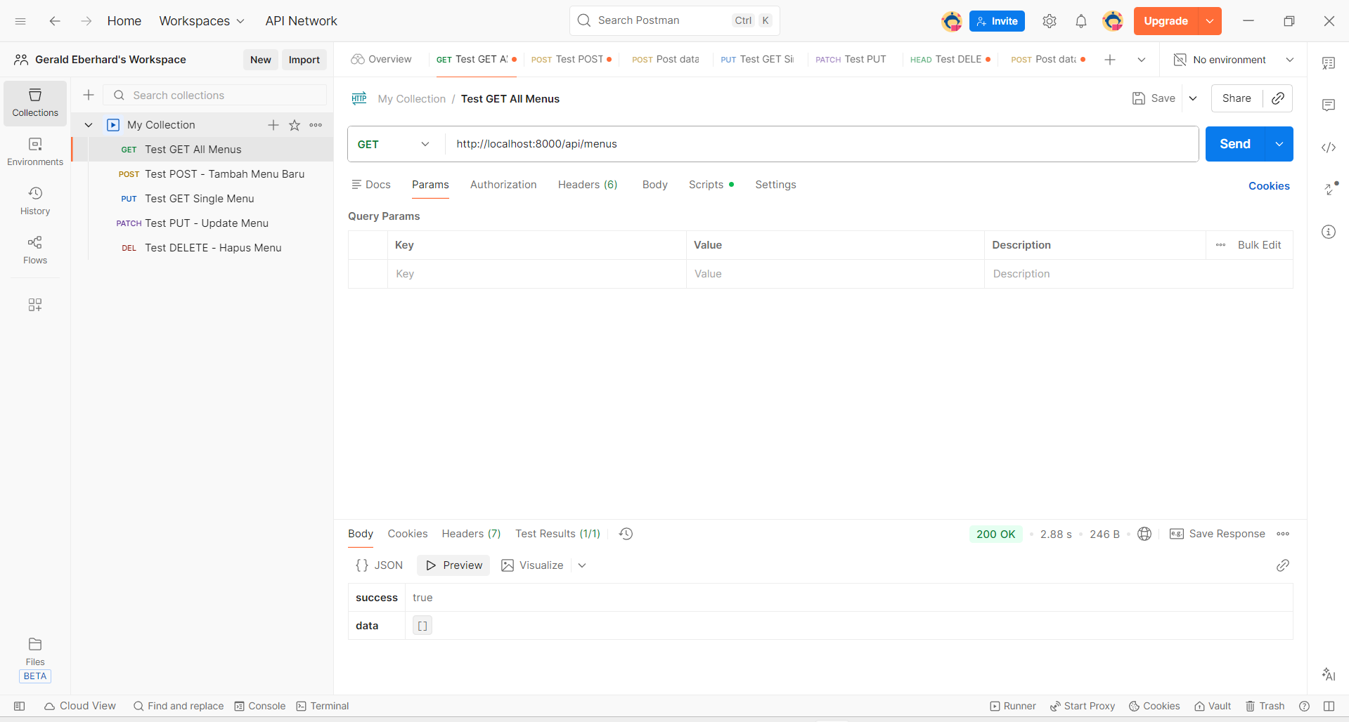
Test POST - Tambah Menu Baru
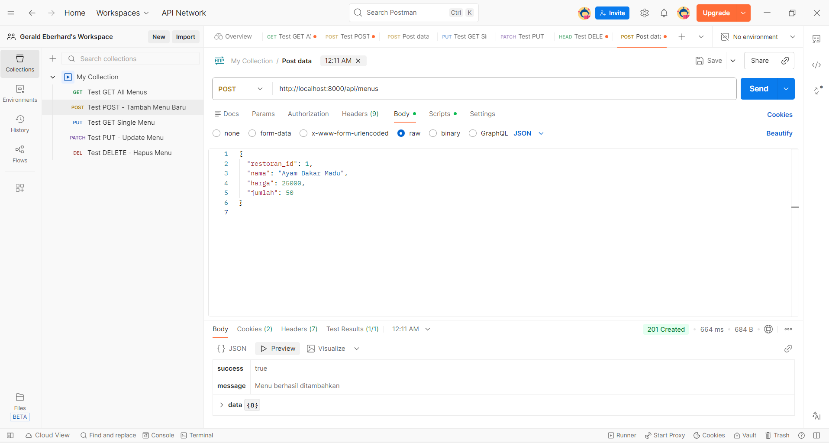

Test GET Single Menu
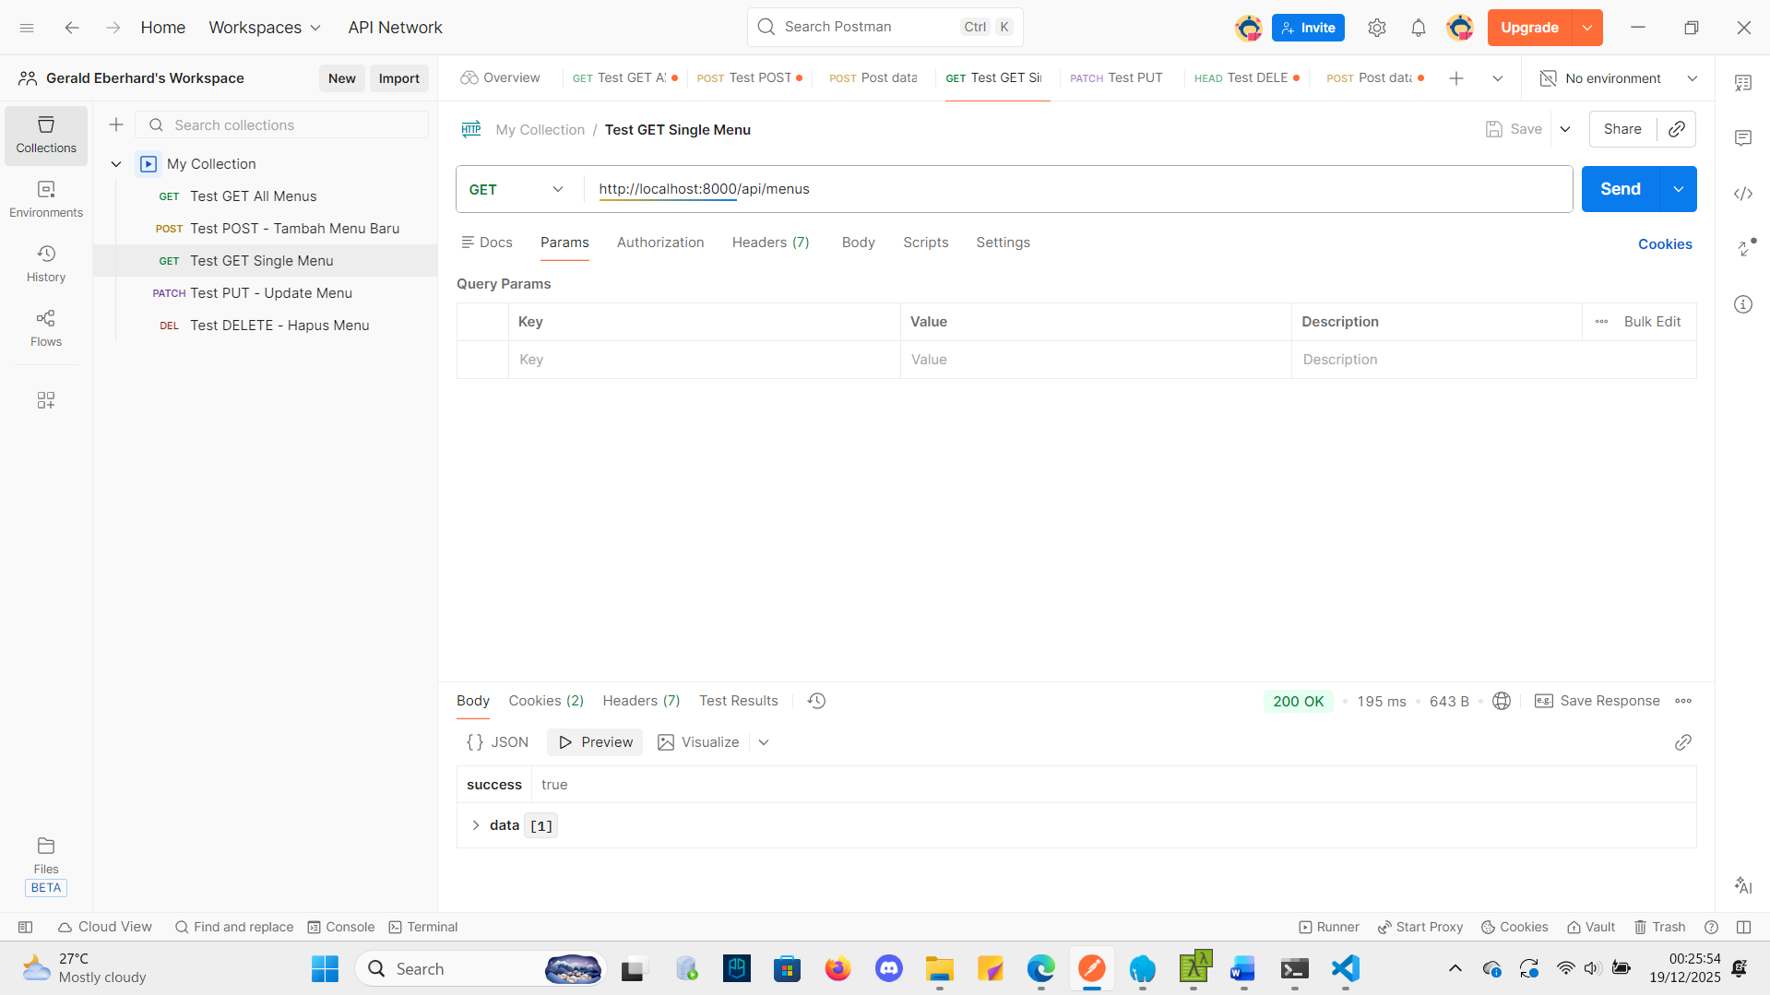
Test PUT - Update Menu
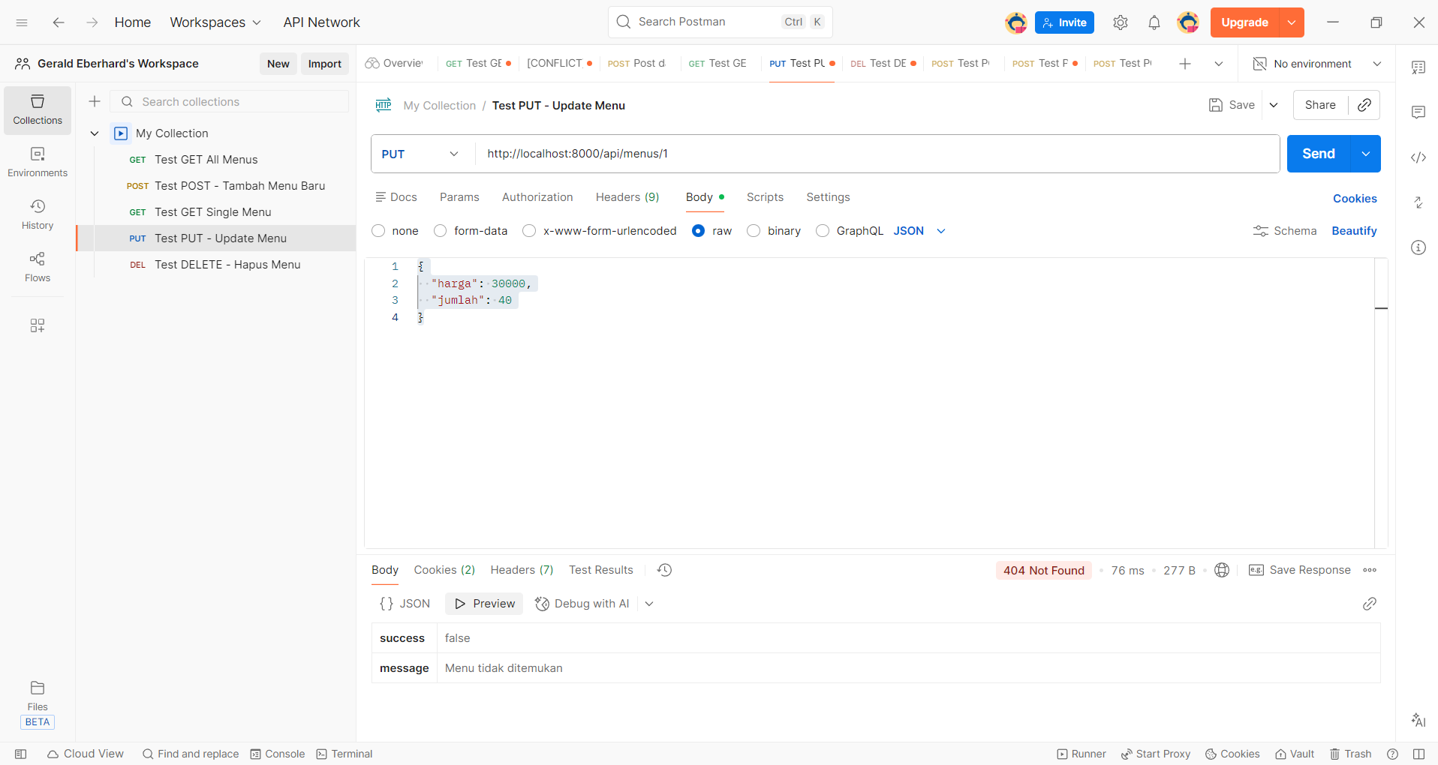

Test DELETE - Hapus Menu
